ACTIVITY DIAGRAM
START
CALCULATE THE VALUE OF SYNCHRONOUS FREQUENCY USING ROTOR FREQUENCY AND SLIP

GET CHOICE AS INPUT AND CALCULATE ACCORDINGLY

GET/INITIALIZE THE VALUES OF ROTOR FREQUENCY,NUMBER OF POLES,ROTOR SPEED,MECHANICAL LOSSES,TORQUE DEVELOPED ,COPPER LOSSES,SLIP AND INPUT POWER

CALCULATE THE VALUE OF SYNCRONOUS SPEED USING SYNCHRONOUS FREQUENCY AND NUMBER OF POLES

CALCULATE THE VALUE OF POWER DEVELOPED USING TORQUE DEVELOPED AND MECHANICAL LOSSES

CALCULATE THE VALUE OF OUTPUT POWER USING POWER DEVELOPED AND

CALCULATE THE VALUE OF SHAFT TORQUE USING OUTPUT POWER AND

CALCULATE THE VALUE OF EFFICIENCY USING INPUT POWER AND OUTPUT POWER

CALCULATE THE VALUE OF TOTAL LOSSES USING INPUT POWER AND OUTPUT POWER

CALCULATE THE VALUE OF ROTOR POWER INPUT USING COPPER LOSS AND POWER DEVELOPED

CALCULATE THE VALUE OF TORQUE DEVELOPED IN FORWARD DIRECTION USING ROTOR POWER INPUT AND TORQUE DEVELOPED

CALCULATE THE VALUE OF TORQUE DEVELOPED IN BACKWARD DIRECTION USINGROTOR POWER INPUT AND TORQUE DEVELOPED

EXIT
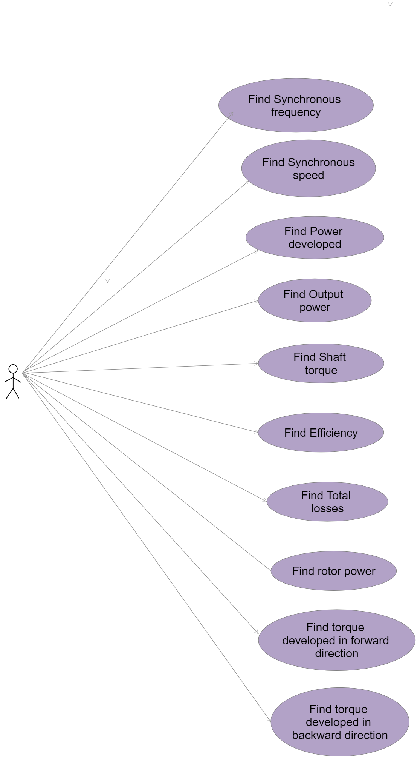
USE CASE DIAGRAM

